# Automated Network Request Management in ServiceNow

This document details the development and implementation of an automated system for managing network service requests within the ServiceNow platform. It covers the project's objectives, scope, technical requirements, and the methodology used to transform a manual, error-prone process into an efficient, user-friendly solution. By leveraging ServiceNow's robust capabilities, this project aims to significantly enhance operational efficiency and elevate customer satisfaction for network-related service requests.

# Project Abstract: Streamlining Network Service Requests

This project focuses on automating the management of network-related service requests such as WiFi, DTH/TV, and Air Fiber connections using ServiceNow. The solution enables end-users to raise service requests through a self-service portal, while backend automation handles approvals, technician assignments, notifications, and follow-ups. By leveraging ServiceNow9s capabilities such as Flow Designer, Business Rules, UI Policies, Notifications, and ATF, the project aims to reduce manual effort, improve efficiency, and deliver faster resolutions. This automation not only accelerates service delivery but also provides greater transparency and a consistent experience for all stakeholders.

# Introduction: The Need for Automation

In today's fast-paced digital environment, manual handling of network service requests is a significant bottleneck. Traditional methods often lead to slow processing times, increased operational costs, and a higher probability of human errors. This not only frustrates customers but also strains IT resources, diverting valuable personnel from more strategic initiatives.

"The biggest challenge wasn't the technical work, but the waiting. Customers expected instant service, and we were stuck in a paper-based limbo."

Our objective for this project is to implement a robust automation solution within ServiceNow that addresses these pain points. By automating the entire lifecycle of network service requests, we aim to achieve faster processing, enhance transparency for both customers and administrators, and ultimately boost overall customer satisfaction. This transition to an automated system is crucial for maintaining a competitive edge and meeting modern service delivery expectations.

# Project Scope: What We're Automating

Defining the scope is crucial for any project's success. For this initiative, we focused on clearly delineating what services and user groups would be included, ensuring a manageable and impactful implementation.

**Key User Groups** Customers (End-Users) Service Technicians Company Admin Team

The system is designed to provide tailored experiences for each user role, optimizing their interactions with the network request process.

**In-Scope Services**

WiFi Connection Requests

DTH/TV Connection Requests

Air Fiber Connection Requests

These services represent the most frequently requested network provisioning tasks, making their automation highly impactful.

**Out-of-Scope Services** General IT Support Tickets Hardware Procurement

Other non-network related IT services

Excluding these ensures focus and prevents scope creep, allowing for a streamlined development process.

# System Requirements

To ensure successful deployment and operation of the automated network request management system, specific hardware and software requirements must be met. The chosen technologies leverage standard enterprise solutions to ensure compatibility and ease of maintenance.

**Hardware Requirements**



 **Workstation:** Standard laptop or desktop computer capable of running modern web browsers efficiently.

 **Connectivity:** Stable internet connection for accessing the ServiceNow instance.

 **Peripherals:** Standard input devices (keyboard, mouse) and a monitor.

These requirements ensure that all users, from customers to administrators, can access and interact with the system without performance issues.

**Software Requirements**

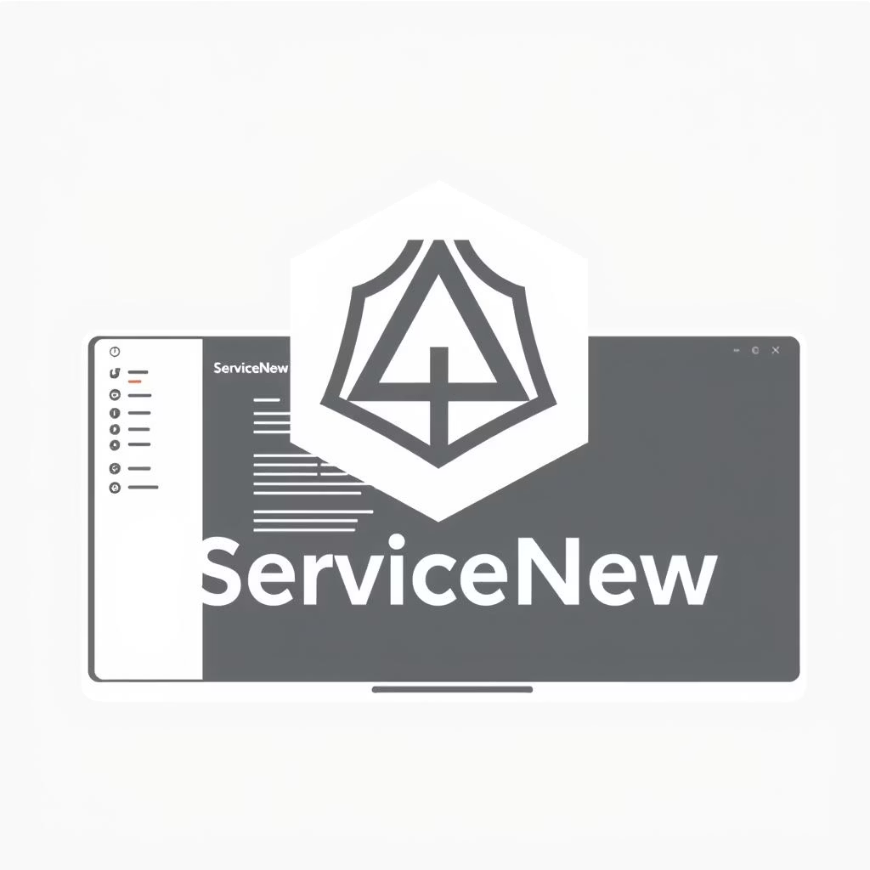

 **ServiceNow Instance:** A dedicated ServiceNow instance (personal developer instance was utilized for development).

 **Automated Test Framework (ATF):** Used for comprehensive testing of workflows, UI policies, and business rules.

 **Web Browser:** Latest versions of Google Chrome, Mozilla Firefox, Microsoft Edge, or Apple Safari for optimal compatibility.

The reliance on ServiceNow's native capabilities and ATF ensures a scalable, secure, and well-tested solution.

# Methodology: Step-by-Step Automation Development

Our development process followed a structured methodology, breaking down the automation into logical, manageable steps. This iterative approach allowed for continuous testing and refinement, ensuring that each component integrated seamlessly into the overall solution.

01

## Request Form Creation

Designed a custom form in ServiceNow for customers to request services (e.g., Jio WiFi). Added mandatory fields for customer details, connection type, required documents, and preferred installation dates.

02

## Automation Rules Configuration

Configured UI Policies and Client Scripts for real-time input validation and dynamic field visibility.

Implemented Flow Designer flows to automatically calculate costs and estimated service durations based on selected options.

03

## Approvals & Assignment Workflow

Created automated workflows to route requests for necessary approvals and assign them to the appropriate company team or technician based on service type and geographical location.

04

## Technician Workflow & Installation

Developed a dedicated technician interface. Technicians receive their assigned requests, perform the installation, and update the request status directly in the system, triggering subsequent automation steps.

05

## Quality Check & Verification

Implemented a stage for service verification. This ensures the newly installed service (e.g., internet speed, DTH channel availability) meets specified quality standards before official closure.

06

## Notifications & Communication

Configured comprehensive email and in-platform notifications for all stakeholders, providing updates on request status, approval requests, technician assignments, and completion alerts.

07

## Data Storage & Management

Designed custom tables and fields within ServiceNow to efficiently store and manage customer data, request details, service history, and technician logs.

08

## Follow-Up & Escalation System

Built scheduled jobs to automatically send reminders for pending actions and escalate requests that exceed defined service level agreements (SLAs).

09

## Automated Testing with ATF

Leveraged ServiceNow's Automated Test Framework (ATF) to rigorously validate all workflows, business logic, UI policies, and data integrity throughout the development lifecycle.

10

## Deployment & Project Closure

Final deployment of the fully tested solution into the production environment, followed by comprehensive documentation and project closure, including an end- user guide and administrator manual.

# System Design: Visualizing the Automation

Understanding the system's architecture is crucial for appreciating its efficiency. We've visualized the core components through diagrams to illustrate the interactions between users, the flow of requests, and the underlying data structure.

### Customer

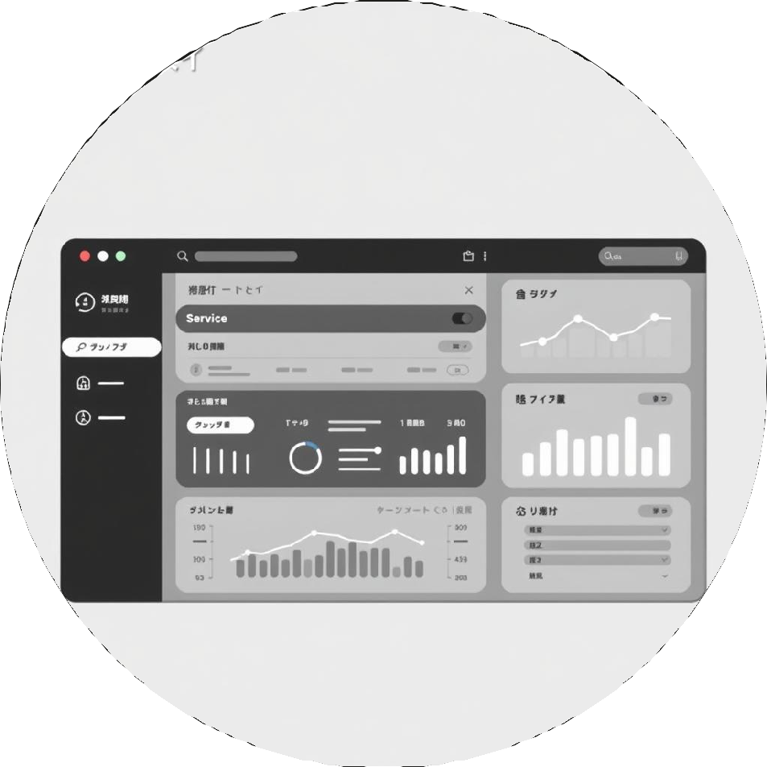

Submit and track

requests

### Company Admin

Approve, assign, monitor SLAs

### Technician

Receive, perform, update, check

This use case diagram highlights the direct interactions of each user role with the system, emphasizing the self- service capabilities for customers and the management functions for admins and technicians.

# System Design: Workflow and Data Structure

## Approval Process

Company admin reviews request

## Installation

Technician performs installation



## Request Submission

Customer creates service request

## Technician Assignment

Assign technician to request

## Quality Check

Verify installation quality

The workflow diagram illustrates the logical progression of a service request, from initial submission to final closure, showcasing the automated steps and human intervention points. The ER diagram provides an overview of the database schema, detailing the entities and their relationships, which forms the backbone of the system's data management.

# Results & Discussion: Impact of Automation

The implementation of this automated system has yielded significant improvements in efficiency and service delivery. Compared to the previous manual process, we've observed a dramatic reduction in resolution times and a marked increase in operational consistency.

6

4

2

0

|  |  |  |  |
| --- | --- | --- | --- |
| Request to Assignment | Assignment to... | Installation to Closure | Total Resolution Time |
|  | Manual (Days) | Automated (Days) |  |

As the chart illustrates, the total resolution time has decreased from an average of 3-5 days for manual processes to a mere 1-2 days with automation. This significant acceleration is primarily due to instant routing, automated approvals, and real-time status updates, eliminating delays caused by manual handoffs and communication gaps. The transparency provided by the self-service portal and automated notifications has also drastically reduced follow-up inquiries, freeing up administrative staff.

# Conclusion & Future Enhancements

This project successfully transformed the laborious, error-prone manual process of managing network service requests into an efficient, automated workflow within ServiceNow. By leveraging various ServiceNow capabilities, we have significantly reduced manual effort, drastically improved service delivery times, and enhanced the overall customer experience. The system provides greater transparency and ensures consistent service quality, positioning the organization for better operational performance.

**Future Enhancements**

Chatbot Integration: Implement a virtual agent for instant query resolution and guided request submission directly within the portal, further reducing the need for human intervention.

AI-based Technician Assignment: Develop an AI/ML model to intelligently assign technicians based on factors such as skill set, current workload, geographical proximity, and past performance, optimizing resource utilization.

Mobile Application Integration: Extend the self-service portal functionality to a dedicated mobile application, allowing customers to submit and track requests, and technicians to manage assignments on the go.

Advanced Analytics & Reporting: Implement more sophisticated dashboards and reporting tools to gain deeper insights into service demand, technician performance, and potential bottlenecks, enabling proactive service management.

RESULTS

